**Physical Therapy Activities for Home**

The following is a list of physical activities in order to increase strength, balance, coordination and improve overall gross motor skills.

Have your child work on a combination of these activities for 20 minutes 2 times a week.

1. Turn on your child’s favorite music and have them dance. (You can join the fun too!)
2. Work with your child on going up and down stairs. Stay close and hold their hand if they need support. Stairs is a great strengthening activity for the legs.
3. Take a ball and play catch, roll it to each other on the floor, and kick it back and forth.
4. Do any fun activities that your child enjoys like coloring or puzzles, while on their belly. This helps to strengthen the back muscles and improves posture.
5. Let your child help you clean up at home. Picking up things from the floor encourages squatting which is a great strengthening activity.
6. Dance to your favorite music.

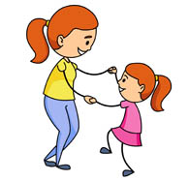

1. Practice going up and down steps.

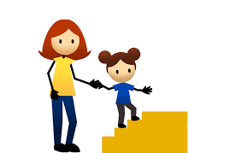

3. Play catch, kick and roll any ball you have at home.

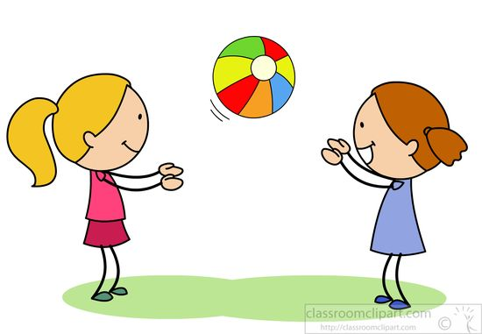

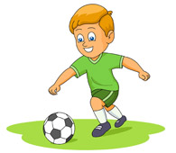

4. Color, draw, play a game on your belly.

.